**Virology**

**User Guide**

|  |  |  |
| --- | --- | --- |
| **Supervisor** | Sir Muhammad Wajahat | |
| **Batch** | 2406F | |
| **Group** | Viruses | |
| **Serial No** | **Enrollment Number** | **Student Name** |
| **1.** | 1584460 | Adnan Ali Khan |
| **2.** | 1577752 | Konain Raza |
| **3.** | 1586871 | Syed Abdus Sami Shah |
| **4.** | 1586843 | Syed Shaheer Shah |

|  |
| --- |
| * ***USER GUIDE*** |

**“VIROLOGY”** This Website is basically educational purpose focusing on Viruses, their Types & related topics. If you were passionate about viruses, you would likely be fascinated by their complexity and impact on life, so this website made for you.

1. **TOP LAYOUT**

**This is the Top of the Page.**

* User can know about the website by clicking on Home.
* User can get touch to the admin by Registering their selves from this page.

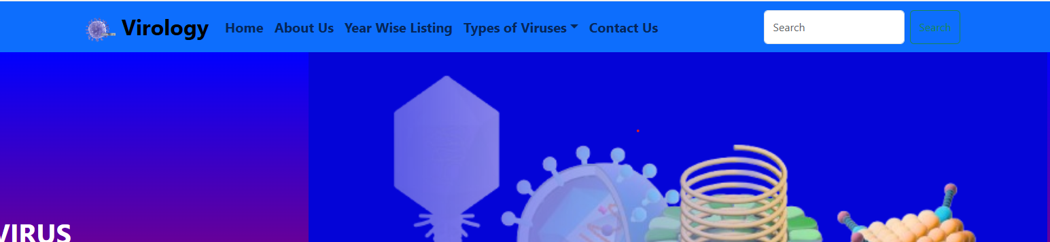

1. **HOME PAGE**

* This page contains Definition of virus, their structure and types.

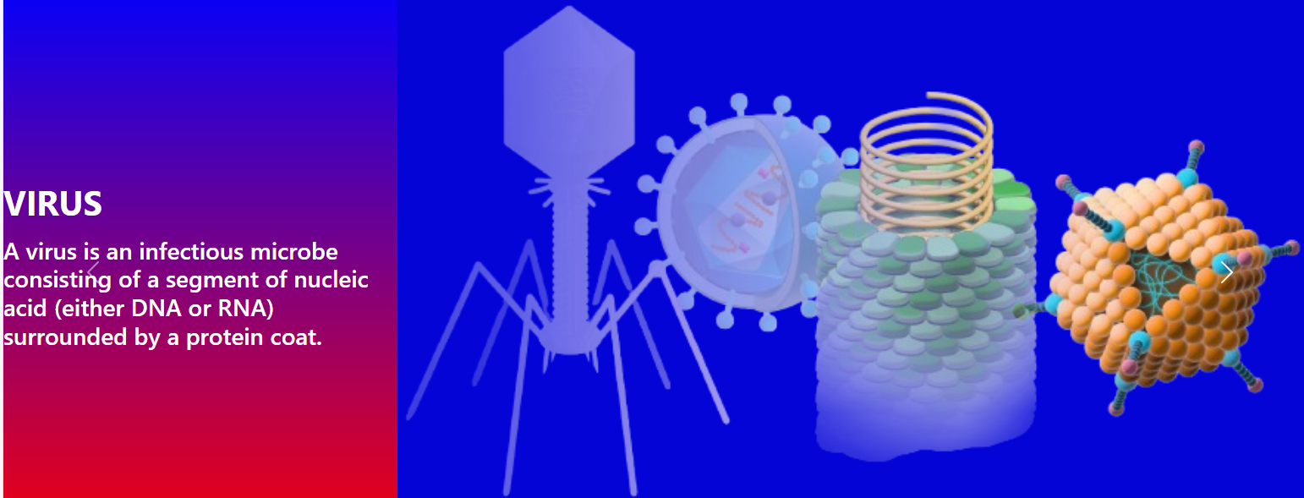

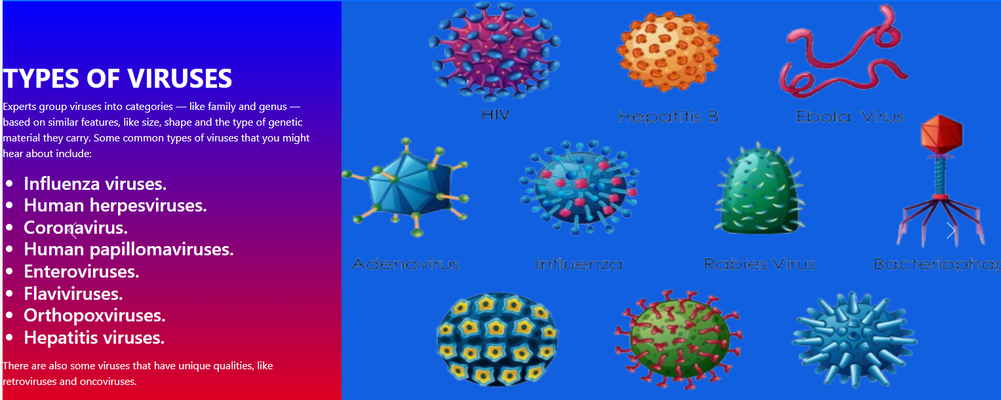 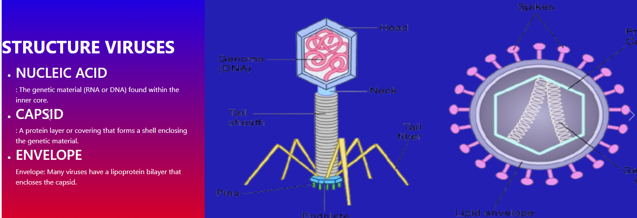

1. **TYPES OF VIRUSES**

* These pages contain types of viruses, their symptom and treatment.

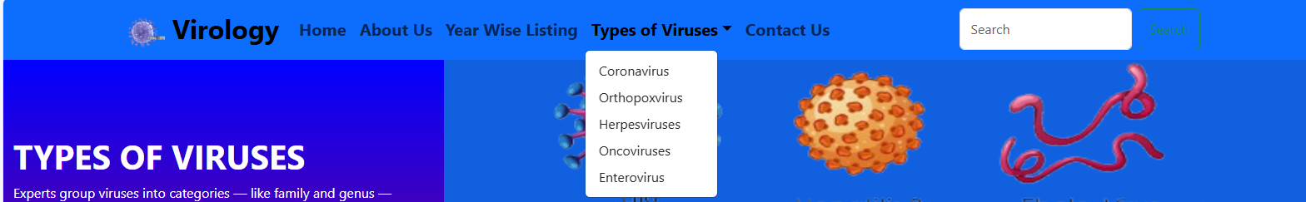

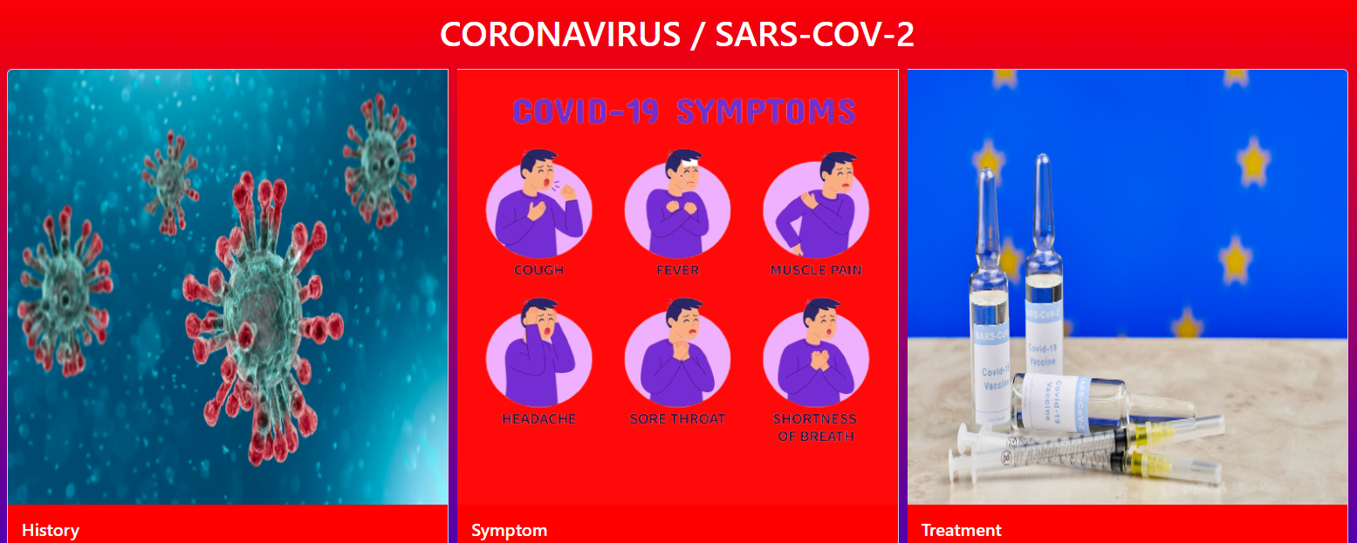  

 

1. **YEAR WISE LISTING**

This is the year wise listing page.

* In this page user can know about details history of mentioned virus.

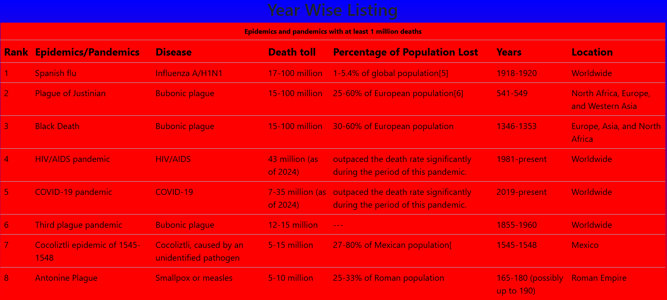

1. **ABOUT PAGE**

This is the About Us Page.

* In this page some information about our team & Website.

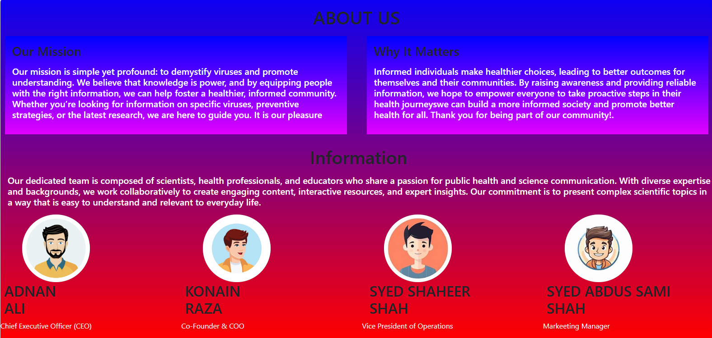

1. **CONTACT PAGE**

This is the Contact Page.

* In this page users can get in touch with us.
* They can leave their comment as Feed Back about website.

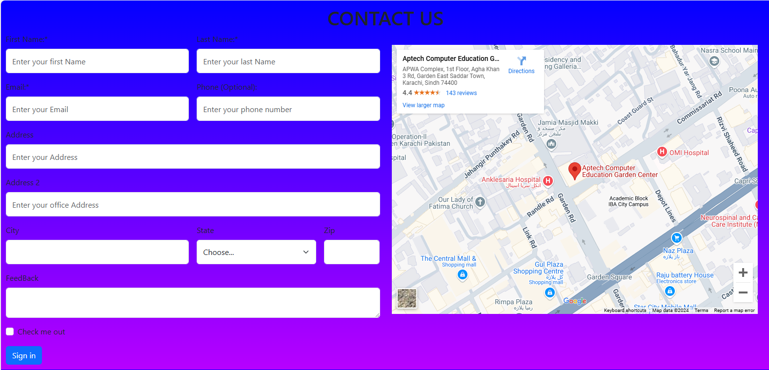

1. **FOOTER PART**

This part belong to footer content .

* In this part users can link with us i.e Facebook, Tweeter.

